Open PDF Files in Solution Explorer

If you have a PDF file in a Visual Studio project and you click on it in Solution Explorer to open it,  
it will open as a binary file in the Visual Studio text editor. Since that is *not* useful, you can tell Visual Studio which application should be used when opening this type of file. Right-click on the file in Solution Explorer and choose "Open With...". Now you can choose which application you want to use. If you have Adobe Reader you can use that or just use Microsoft Edger as shown below.  
Set this application as the default and Visual Studio will always use it for this file type.

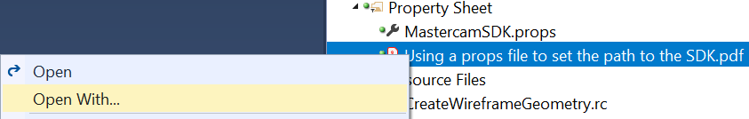

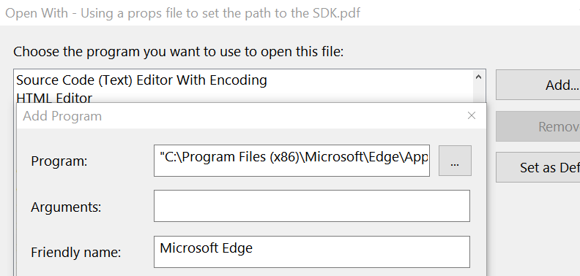

If you encounter any issues with what is (or not) documented here, please let us know!

[sdk@mastercam.com](mailto:sdk@mastercam.com?subject=Open%20PDF%20Files%20in%20Visual%20Studio%20doc)

CNC Software, Inc. | 671 Old Post Road | Tolland, CT 06084 | USA   
Phone: 860.875.5006 | Fax: 860.872.1565 | [www.mastercam.com](http://www.mastercam.com/)

[](http://www.mastercam.com/)